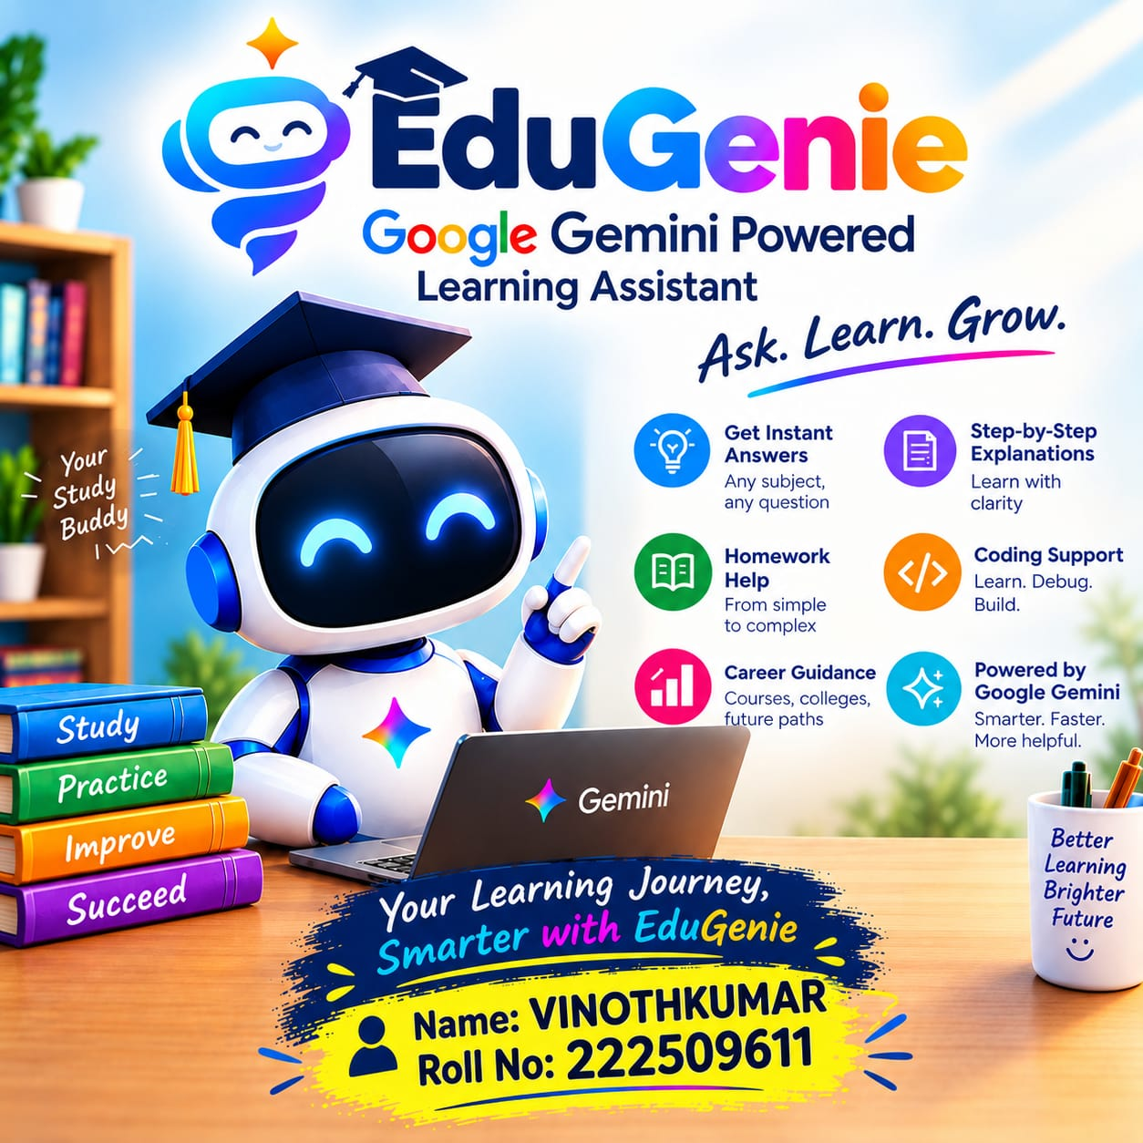
Google Gemini Powered Learning Assistant
PROJECT REPORT

Abstract
EduGenie is an AI-powered educational assistant designed to help students learn through natural-language interaction. The application uses the Google Gemini API to provide explanations, homework guidance, coding assistance, study support, and general career guidance. The project combines a responsive web interface with a server-side backend so that students can submit questions and receive generated educational responses.

Technology Stack
Frontend: HTML5, CSS3 and JavaScript
Backend: Node.js and Express.js
Artificial Intelligence: Google Gemini API
API SDK: Google GenAI JavaScript SDK

PAGE 1 — INTRODUCTION

1. Introduction
Education is increasingly supported by digital technologies and Artificial Intelligence. Students often need quick explanations for difficult concepts, assistance with assignments, programming guidance, and help preparing for examinations. EduGenie is proposed as a virtual learning companion that can provide interactive assistance whenever a student has a question.

2. Problem Statement
Students may not always have immediate access to a teacher or tutor. Searching across many sources can also be time-consuming, while technical explanations may be difficult for beginners. A conversational AI assistant can provide a single interface for asking questions and receiving understandable explanations.

3. Proposed Solution
EduGenie connects a student-friendly web interface to Google Gemini through a backend server. The student enters a question, the server sends the request to Gemini, and the generated response is returned to the interface. The system is designed to encourage understanding through explanations and step-by-step guidance rather than only presenting final answers.

4. Objectives
- Provide an intelligent learning assistant.
- Explain difficult concepts in simple language.
- Support homework and revision activities.
- Assist with programming questions.
- Provide general course and career information.
- Encourage self-learning and interactive study.

PAGE 2 — FEATURES AND MODULES

5. Major Features
AI Question Answering: Students can enter questions in natural language and receive AI-generated explanations.
Tutor Mode: Provides concept-focused explanations and examples.
Homework Mode: Guides students through academic problems and encourages understanding.
Coding Mode: Helps explain programming concepts and code-related problems.
Career Mode: Provides general information about courses, skills, and career paths.
Responsive Interface: The web interface is designed to work across common screen sizes.

6. System Modules
- User Interface Module — Provides the question box, mode selection, and response display.
- Request Processing Module — Validates and prepares the student's question.
- Gemini Integration Module — Sends the request to the Gemini API and receives the response.
- Learning Assistance Module — Applies learning-oriented instructions for different modes.
- Response Display Module — Presents the generated answer in a readable format.

7. Advantages
- Quick access to learning assistance.
- Interactive question-and-answer experience.
- Useful for multiple learning activities.
- Beginner-friendly explanations.
- Can be expanded with additional educational features.

PAGE 3 — SYSTEM DESIGN AND WORKING

8. System Architecture
Student → EduGenie Web Interface → Node.js/Express Backend → Google Gemini API → Generated Response → Student

9. Working Process
Step 1: The student opens EduGenie and selects a learning mode.
Step 2: The student enters a question or learning request.
Step 3: JavaScript sends the request to the backend endpoint.
Step 4: The backend creates a learning-oriented prompt and sends it to Gemini.
Step 5: Gemini generates the response.
Step 6: The backend returns the response to the browser.
Step 7: EduGenie displays the answer to the student.

10. Project Structure
EduGenie/
■■■ public/
■ ■■■ index.html
■ ■■■ style.css
■ ■■■ app.js
■■■ server.js
■■■ package.json
■■■ .env.example
■■■ README.md

11. Security
The Gemini API key should remain on the server and be stored in an environment variable. It should not be placed in browser-side JavaScript or committed to a public repository.

PAGE 4 — FUTURE SCOPE AND CONCLUSION

12. Future Enhancements
- Voice input and voice responses.
- Tamil and multilingual support.
- AI-generated quizzes and practice tests.
- Personalized study plans.
- Student progress tracking.
- PDF and document question answering.
- Image-based question understanding.
- Learning dashboards and analytics.

13. Limitations
AI-generated responses can sometimes be incorrect or incomplete. Students should verify important academic information with teachers, textbooks, and reliable sources. The application also depends on network connectivity and availability of the configured AI service.

14. Conclusion
EduGenie demonstrates how generative AI can be integrated into an educational web application. By combining a simple interface, a backend service, and Google Gemini, the project provides an interactive learning assistant for questions, explanations, homework support, coding assistance, and general educational guidance. The modular design also makes it suitable for future extensions such as quizzes, multilingual support, voice interaction, document analysis, and progress tracking.

15. References
Google AI for Developers — Gemini API documentation and API reference. The official documentation describes the Gemini API, authentication, SDKs, and application integration patterns.
Project Title: EduGenie: Google Gemini Powered Learning Assistant

